SUPPORT DOCUMENT

FOR

**Handling Dropdown Voluminous Options**

If there is requirement of displaying a dropdown with tons of options in a web page. We can't load all the options at a time because it is going to take a lot of time which is very bad experience for users while accessing the site.

In this asset, we discuss about the solution for the above problem using the PrimeNG (framework provided) and Angular material (Manual solution).

**Benefits of this Asset:**

User gets to learn about how to handle dropdown having infinite number of options in it. There are two solutions provided: using primeNG framework and Angular material.

User will have understanding about the **lazy loading**, **scroll events** and **directives** which can be used in a dropdowns. Lazy loading is a technique in which only certain parts of webpage will be loaded until they are needed.

Instead of loading all the resources of page at once which include unused, unnecessary resources by using lazy loading technique only the necessary resources will be loaded/imported.

There are two solutions provided: using primeNG framework and Angular material which can be used in their project by following the steps mentioned in the asset.

**Prerequisites to run the application:**

It’s an angular application which runs on node js, so we need to have node JS installed in your system.

You need to have node modules present in your application folder.

Install by using command: **npm install**

You need to have angular framework installed.

Install it by using command: **npm install -g @angular/cli**

Used primeNG and material UI as styling framework for styling the application so you need to have them installed in modules.

Install it by using command: **npm i primeng**

Install it by using command: **ng add @angular/material**

After installing all required dependencies, you need to serve the application to run it.

Run it by using command: **ng serve**.

By default, application will serve at <http://localhost:4200>

**Application explains about:**

Below are the two different ways which we can achieve the above requirement:

**1.Using PrimeNG dropdown:**

<p-dropdown></p-dropdown>

We have properties [virtualScroll]="true" and [virtualScrollItemSize]="5"

Where 5 stands for number of options to be loaded into dropdown:

<p-dropdown [options]="options"

placeholder="Select Item" [virtualScroll]="true"

[virtualScrollItemSize]="5">

</p-dropdown>

**2.Using Angular material dropdown:**

To implement a Dropdown using Angular material, we need to add the required material tags - "mat-form-field" tag in which we define "mat-label" tag to display required label and "mat-select" tag to display a dropdown and "mat-option" tag to display the required options in a dropdown.  
  
Using "infiniteScroll" event which triggers on scroll action of user over the dropdown options, we can implement lazy loading to add next set of options according to the given limit "msInfiniteScroll" directive is required to trigger the "infiniteScroll" event when it reaches the end of dropdown options.

<mat-form-field>

<mat-label>Select Option</mat-label>

<mat-select placeholder="Select an item"

(infiniteScroll)="getNextBatch()" msInfiniteScroll

[complete]="offset === options.length">

<mat-option *ngFor="let option of options$ | async" [value]="option">

{{option}}

</mat-option>

</mat-select>

</mat-form-field>

**About application**

This application contains three different components.

Components to refer:

dropdown-scroll component

This component basically contains dropdowns.

dropdown-all component

This component contains details of dropdown.

dropdown-code-details component

This component contains code for dropdown and their description.

Snapshots of application are provided in the next page…

Application basically lands on dropdown-scroll component by default:

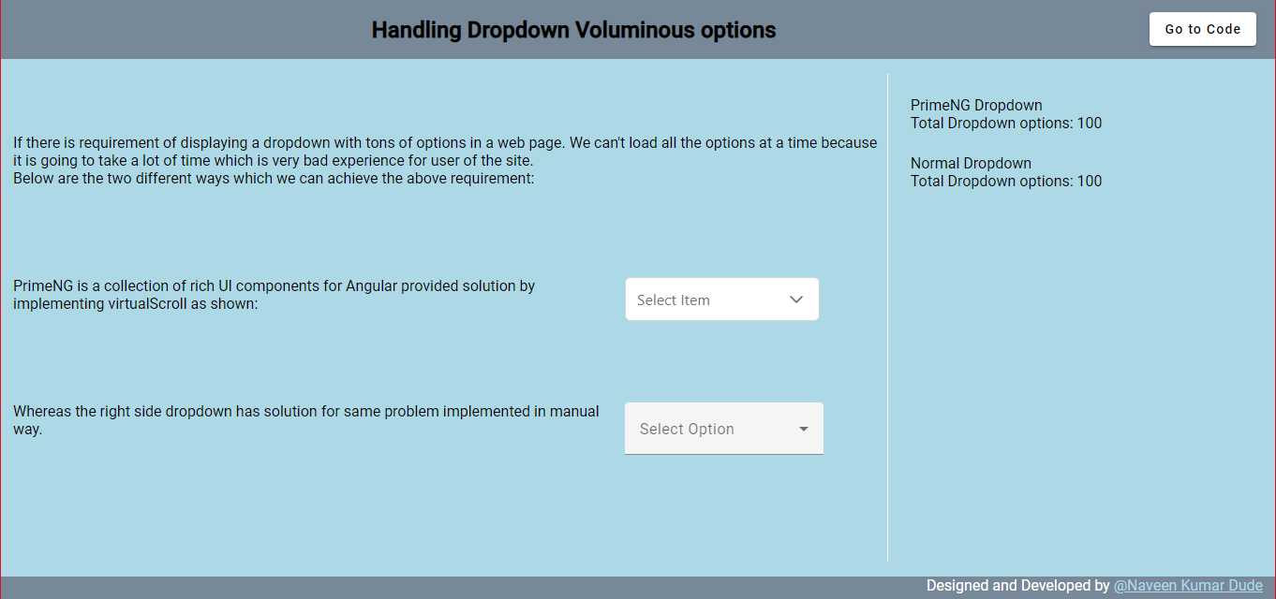

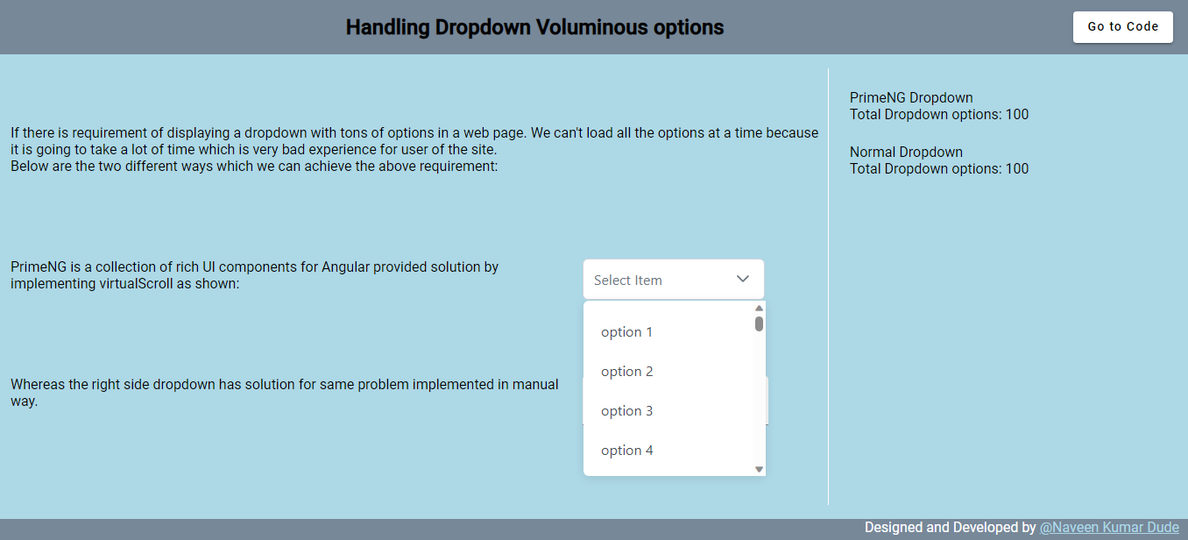

we can navigate by using ‘Go to code’ button and navigate back by using ‘Home icon’ button in the header of the page. 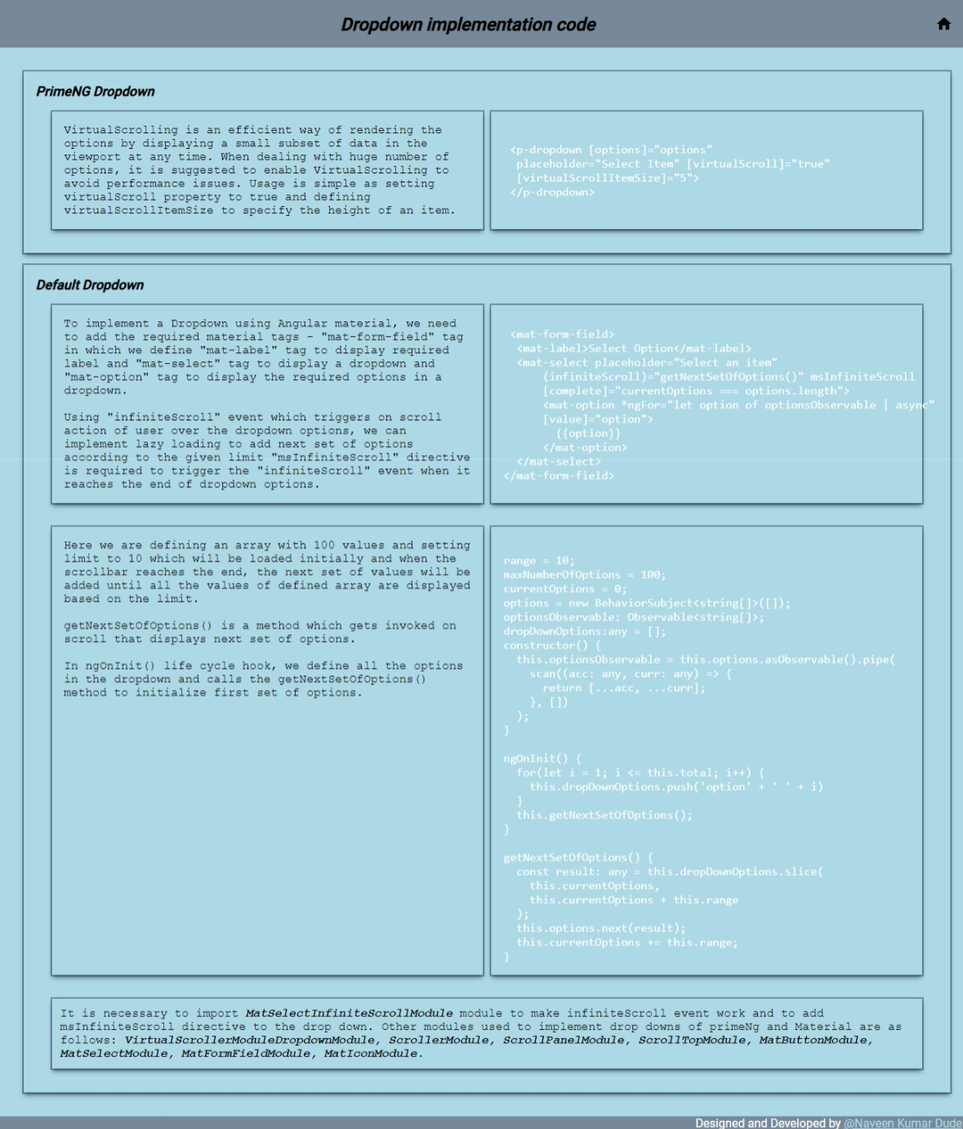

**Reusability of the dropdowns mentioned in this project:**

Suppose user needs to handle a dropdown of similar kind, they can simply copy

and paste the code I have provided in the asset and import all the necessary modules to run the application.

**Execution steps:**

After successfully serving the application, we can access it at port number 4200.

User will land on home page where two dropdowns are displayed, which user can access.

User can click on dropdown and scroll then the new options will be lazy loaded and appended to existing options.

**Input:** click and scroll on dropdowns.

**Output:** lazy loading next set of dropdown options.

**External references:**

[Angular Dropdown Component (primefaces.org)](https://www.primefaces.org/primeng-v15-lts/dropdown)

[javascript - how to use scroll event in angular material mat select? - Stack Overflow](https://stackoverflow.com/questions/48605953/how-to-use-scroll-event-in-angular-material-mat-select)

[Ng Mat Select Infinite Scroll - StackBlitz](https://stackblitz.com/edit/ng-mat-select-infinite-scroll?file=src%2Fapp%2Fapp.component.ts)

[What is lazy loading? | Cloudflare](https://www.cloudflare.com/learning/performance/what-is-lazy-loading/#:~:text=Lazy%20loading%20is%20a%20technique,that%20the%20resources%20are%20needed.)